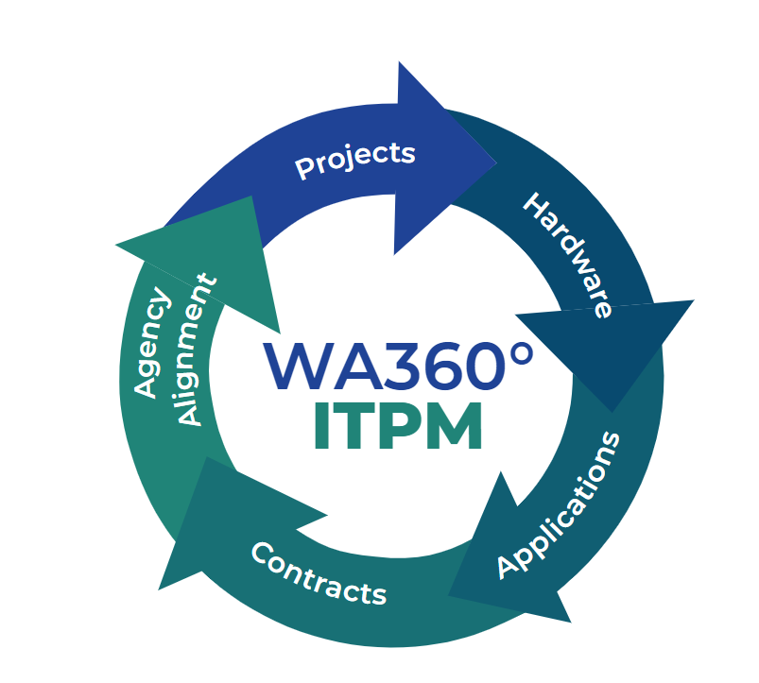

Information Technology Portfolio Management Guide

2 May 2023

Jeremy Schlake

##### 

**Table of contents**

Chapter 1: Preface 4

What is an IT portfolio? 4

What is portfolio management and why is it important? 4

Chapter 2: Background 6

Revised Code of Washington 6

OCIO Policies 7

Statewide IT Strategic Plan 8

WaTech Vision, Mission, and Values 9

How is ITPM different from project portfolio management? 10

Chapter 3: WaTech IT Portfolio Framework 10

What does the WaTech portfolio do? 10

Who does the WaTech portfolio affect? 11

Strategic IT Portfolio Framework 12

**Agency Alignment** 12

**Current policies** 12

**Project Inventory** 13

**Application Inventory** 14

**Hardware Inventory** 15

**Contract Inventory** 16

**Budgetary Trends** 16

**IT Stakeholders** 16

Chapter 4: IT Portfolio Element Sub-Categories 17

Sub-Categorical Approach to Portfolio Elements 17

**Agency Alignment – Mission:** 18

**Agency Alignment – Vision:** 18

**Agency Alignment – Initiatives:** 18

**Agency Alignment – Strategy:** 18

**Current Policies – Policies:** 18

**Current Policies – Policy Waivers for state IT policies:** 19

**Current Policies – ITPM Guide:** 19

**Current Policies – Business Owners Guide:** 19

**Project Inventory – Projects:** 19

**Project Inventory – IT Project Assessment:** 19

**Application Inventory – Applications:** 19

**Application Inventory – Databases:** 19

**Application Inventory – Services Offered:** 19

**Application Inventory – Services with Disaster Recovery Plans:** 19

**Application Inventory – Service Units by Customer:** 20

**Hardware Inventory – Network Inventory:** 20

**Hardware Inventory – Security Inventory:** 20

**Hardware Inventory – End User Inventory:** 20

**Hardware Inventory – Immutable Back-ups:** 20

**Contract Inventory:** 20

**Financial Trends – Budget Data:** 20

**Financial Trends – Expenditures:** 20

**Financial Trends – Cost Centers:** 20

**Financial Trends – Decision Packages:** 20

**IT Stakeholders – Governance:** 21

**IT Stakeholders – Customers:** 21

Chapter 5: ITPM Program Techniques 21

ITPM Inventory Collection 21

ITPM Trend Analysis 24

ITPM Reporting 26

ITPM Maturity Efforts 31

Contact 34

References 34

# Chapter 1: Preface

What is the purpose of this guide?

This guide is a resource to establish the concepts of information technology portfolio management (ITPM) as a holistic approach to the portfolio management domain. This guide is also a resource to help ITPM managers learn how to implement their own program through this modernized concept of portfolio management. It provides an overall framework for ITPM, different interchangeable modules that can be utilized to meet organizational needs, and templates that will be useful in the administration and maintenance of a high-quality ITPM program.

This guide is only one tool among many in the industry. It is intended to be flexible and scalable to any organization within any sphere of influence such as private sector, public sector, and non-profit organizations. Not all organizations require a large and intricate portfolio to be effective and this guide will help you as an ITPM manager select the components that will be effective in your duties to properly analyze business services and investments and to provide sound strategic data for decision-making at the executive leadership level within the organization.

## What is an IT portfolio?

An IT portfolio (hereafter referred to as “portfolio”) is a collection of investments, projects, inventory, and activities that have quantitative metrics of organizational business functions and services. The assets within an organization outline the portfolio. Assets are defined per the State of Washington OCIO as “Anything that has value to an organization, including, but not limited to, another organization, person, computing device, information technology (IT) system, IT network, IT circuit, software (both an installed instance and a physical instance), virtual computing platform (common in cloud and virtualized computing), and related hardware (e.g., locks, cabinets, keyboards). “A portfolio must also include qualitative metrics which drive future services and associated equipment procurement. A portfolio goes further by analyzing an organization’s portfolio through an approach of cumulative IT elements such as projects, applications, infrastructure, and services and combining the multiple activities into a comprehensive collection and continuously improving physical and logical systems to outline the current status of financial requirements, advise potential areas of cost-reduction, propose improvements to customer-facing services and support, and advise on potential areas of inventory management to improve efficient use of available resources.

*An asset is anything that has value to an organization, including, but not limited to, another organization, person, computing device, information technology (IT) system, IT network, IT circuit, software (both an installed instance and a physical instance), virtual computing platform (common in cloud and virtualized computing), and related hardware (e.g., locks, cabinets, keyboards).*

## What is portfolio management and why is it important?

According to the Project Management Institute, portfolio management ensures that an organization can leverage its project selection and execution success. They further go into explaining that “… (project portfolio management) focuses on doing the right projects at the right time by selecting and managing projects as a portfolio of investments.” Regarding ITPM, projects are just a percentage of the entire portfolio. The goal of ITPM is to take all the investments, projects, inventory, and activities, analyze them through the perspective of organizational mission, vision, and goals, and develop strategic pathways in the attempt to reduce waste and increase effectiveness of these multiple metrics.

The importance of ITPM is multifaceted. The realm of IT is constantly changing due to technological breakthroughs. With this ever-changing environment, an organization should always evaluate and analyze current physical and logical assets and review if they are; still modern assets and supported by vendors or if the assets have stopped being supported or are outside the organization’s end of life terms; if there are improvements that can provide cost-benefit to the organization; if there is potential increase in customer services and support; or if there are improvements to the overall health of the portfolio with a forward leaning approach. The following are some of the major benefits of conducting comprehensive ITPM.

**Improved Strategic Picture**

The primary benefit of ITPM is to significantly improve the strategic picture of an organization’s portfolio. Having an improved roadmap of how the organization is to grow within their mission and vision allows executive leaders make better decisions on how to manage their existing assets and work force and where to focus IT budgets to best meet the organizational alignment.

**Organizational Alignment**

Organizational IT requirements will typically help an organization operate but in many cases the use of IT assets fails to support proper governance. To ensure that IT procurement and incorporation within an organization requires a focused alignment with the agency’s mission, vision, and goals. This must be a determined and continuous effort to match every aspect of an ITPM with the organizational alignment. ITPM being aligned with the organization’s mission and vision ensures that every piece of the portfolio is beneficial to the organization and in the aspect of government ensures that constituents’ interest is effectively executed on a financial basis.

**Agency Collaborative Effort**

Enacting a thorough ITPM program allows all parts of the organization to act with singular focus of benefiting the services and support that the agency provides. This is done through collective use of resources and efforts through the ITPM program by providing a road map for projects and existing IT assets and guidance to modernize business systems.

**Reasoned Decision-Making**

Executive leaders set the overall direction of an organization and provide the end-state approval of all services and support provided by the business functions. Utilizing an improved strategic picture, the executive team can use reasoned decision-making to increase efficiency and value of all dispensation of governance amongst the agencies.

**Increased Inventory Prioritization**

With greater alignment and increased decision-making, inventory prioritization within the organization is allowed to happen. Aligning current assets and inventory and prioritizing which IT procurement will have the best impact on the organization, the executive leadership can better invest in future IT assets and divest from systems that do not provide positive results for the organization. Prioritization impacts the overall gain of the agency in terms of financial goals and production of services and support for customers.

**Greater Performance Data Accuracy**

The ITPM program analyzes data inputs to determine not only how to better improve the portfolio but also provides this data to executive leadership for support of their reasoning. This provides a greater accuracy of performance data that facilitates greater executive leader sponsorship of opportunities for the agency.

**Decreased Risk**

Along with greater accuracy and improved use of portfolios, this decreases the risk to the organization by removing the misapplication and misappropriation of IT resources. A lean and agile portfolio improves the use of IT budgets and creates a more accurate allocation on an annual basis.

**Enhanced Return on Investment**

Overall, all of the other benefits of ITPM programs are to increase the return on investment regarding IT budgetary resources. According to the most recent Flexera State of IT Asset Management (ITAM) Report[1], almost a third of IT spending was underutilized or wasted. This provides a weak return on investment (ROI) and has the potential to derail high priority services that the organization provides.

# Chapter 2: Background

To ensure WaTech can provide agency alignment, a comprehensive background must be established before building out an ITPM framework. The following provide reference for this development.

## Revised Code of Washington

The Washington State Legislature from time to time develops and enacts laws that drive the regulation of Washington State agencies. These laws are codified as Revised Code of Washington (RCW). A decent understanding of RCW’s assists in proper execution of processes within agencies. Particular RCWs are utilized for IT governance and are of importance to the daily business of WaTech. The following RCWs are those that impact the ITPM program:

[**RCW 43.88.092 – Information technology budget detail – Information technology plan – Accounting method for information technology**](https://app.leg.wa.gov/RCW/default.aspx?cite=43.88.092)

[**RCW 43.105.006 – Consolidated technology services agency - Purpose**](https://app.leg.wa.gov/RCW/default.aspx?cite=43.105.006)

[**RCW 43.105.007 - Purpose**](https://app.leg.wa.gov/RCW/default.aspx?cite=43.105.007)

[**RCW 43.105.020 - Definitions**](https://app.leg.wa.gov/RCW/default.aspx?cite=43.105.020)

[**RCW 43.105.052 – Powers and duties of agency**](https://app.leg.wa.gov/RCW/default.aspx?cite=43.105.052)

[**RCW 43.105.054 – Governing information technology – Standards and policies – Powers and duties of office**](https://app.leg.wa.gov/RCW/default.aspx?cite=43.105.054)

**[RCW 43.105.111 – Performance targets – Plans for achieving goals – Quarterly reports to governor](https://app.leg.wa.gov/RCW/default.aspx?cite=43.105.111)**

**[RCW 43.105.205 – Office of the state chief information officer – Created – Powers, duties, and functions](https://app.leg.wa.gov/RCW/default.aspx?cite=43.105.205)**

[**RCW 43.105.220 – Strategic information technology plan – Biennial performance reports**](https://app.leg.wa.gov/RCW/default.aspx?cite=43.105.220)

[**RCW 43.105.225 – Managing information technology as a statewide portfolio**](https://app.leg.wa.gov/RCW/default.aspx?cite=43.105.225)

[**RCW 43.105.230 – State agency information technology portfolio – Basis for decisions and plans**](https://app.leg.wa.gov/RCW/default.aspx?cite=43.105.230)

[**RCW 43.105.235 – State agency information technology portfolio - Exemptions**](https://app.leg.wa.gov/RCW/default.aspx?cite=43.105.235)

[**RCW 43.105.240 – Evaluation of agency information technology spending and budget requests**](https://app.leg.wa.gov/RCW/default.aspx?cite=43.105.240)

[**RCW 43.105.245 – Planning, implementation, and evaluation of major projects – Standards and policies**](https://app.leg.wa.gov/RCW/default.aspx?cite=43.105.245)

[**RCW 43.105.265 – Enterprise-based strategy for information technology – Use of ongoing enterprise architecture program**](https://app.leg.wa.gov/RCW/default.aspx?cite=43.105.265)

[**RCW 43.105.341 – Information technology portfolios**](https://app.leg.wa.gov/RCW/default.aspx?cite=43.105.341)

## OCIO Policies

To enact RCW’s in WaTech, the Office of the Chief Information Officer (OCIO) provides the agency and other State agencies with policies. Certain policies are created to guide the governance of ITPM. The following OCIO policies are:

[Policy 101 – Technology Policies and Standards](https://ocio.wa.gov/policy/technology-policies-and-standards)

[Policy 103 – Technology Policy & Standard Waiver Request](https://ocio.wa.gov/policy/technology-policy-standards-waiver-request)

[Policy 112 – Technology Portfolio Foundation](https://ocio.wa.gov/policy/technology-portfolio-foundation)

[Policy 112.10 – Technology Portfolio Foundation – Applications](https://ocio.wa.gov/policy/technology-portfolio-foundation-applications)

[Policy 112.20 – Technology Portfolio Foundation – Infrastructure](https://ocio.wa.gov/policy/technology-portfoliio-foundation-infrastructure)

[Policy 112.30 – Managing Information Technology Portfolios Standards – Projects](https://ocio.wa.gov/policy/managing-information-technology-portfolio-standards-projects)

[Policy 113 – Technology Business Management (TBM)](https://ocio.wa.gov/policy/technology-business-management-tbm)

[Policy 113.10 – TBM IT Expenditure Data Provision Standard](https://ocio.wa.gov/policy/tbm-it-expenditure-data-provision)

[Policy 113.30 – TBM Taxonomy](https://ocio.wa.gov/policy/tbm-taxonomy-standard)

## Statewide IT Strategic Plan

Part of ITPM is to analyze and review individual portfolio pieces against the organization’s vision, mission, principles, and the goals of the organization. The State of Washington develops a Statewide Information Technology Plan that outlines all of these parameters in a file found on the OCIO website.

**Vision**

Better Government Through Technology

**Mission**

Personalize and Optimized Government

**Principles**

Leadership, Enterprise Focused, Agility, Transparency, Data Driven

**Goals**

Efficient & Effective Government, Accountable IT Management, IT Workforce, Enterprise Architecture, Security & Privacy

## WaTech Vision, Mission, and Values

WaTech ITPM must fit the WaTech Vision, Mission, and Values. These details are fine-tuned from RCW’s, OCIO policies, and the statewide IT strategic plan.

**Our Vision**

*To be the trusted leader and technology partner of choice.*

**Our Mission**

*Advancing Washington’s technology strategies and services.*

**Our Guiding Principles**

* *Customer focused*
* *Deliver quality solutions*
* *Lead with integrity*
* *People first*
* *Service driven*

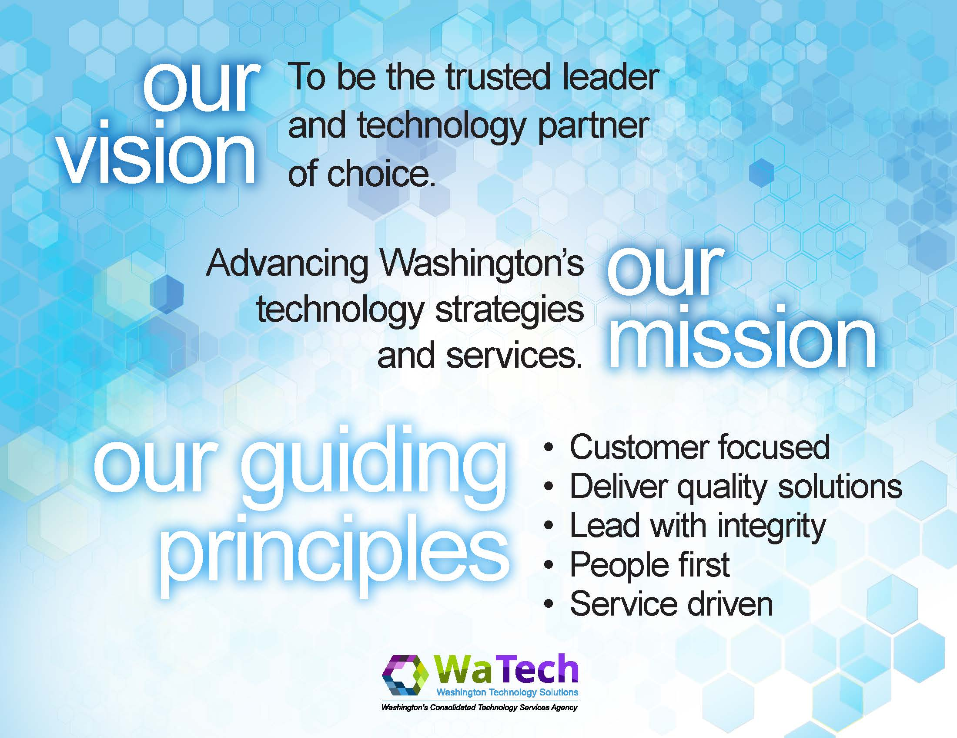

Figure 1: WaTech Vision, Mission, and Principles

## How is ITPM different from project portfolio management?

Project portfolio management (PPM) focuses solely on improving the project workload to best impact the organization. The PMBOK Guide 5th Edition published in 2013 by Project Management Institute defines portfolio management as, *“Portfolio management focuses on ensuring that projects and programs are reviewed to prioritize resource allocation, and that management of the portfolio is consistent with and aligned to organizational strategies.”*

*“Portfolio management focuses on ensuring that projects and programs are reviewed to prioritize resource allocation, and that management of the portfolio is consistent with and aligned to organizational strategies.”*

*PMBOK Guide 5th Edition, Project Management Institute*

Most organizations approach portfolio management from the PPM strategy. In larger organizations, this potentially leaves millions of dollars of waste. PPM does not focus on any other aspects of IT governance within agencies but that does not relinquish the organization’s requirements to provide best utilization of resources for investors and customers. In government, investors are the customers and the requirement to provide efficient and reliable IT governance is of utmost importance.

ITPM focuses on not only the project portfolio but existing applications, infrastructure, programs, business processes, waivers, products, and services. This conglomeration of different aspects of the business requires a wider lens to provide best value for not only executive leadership but also business owners, managers, and customers. The financial efficiency of the organization also is not the only focus of ITPM; it provides strategic direction for future IT investments, developing business processes, advancing the experience and knowledge of ITPM techniques, and advising on current portfolio management. ITPM is a holistic approach to guiding an organization’s IT footprint.

# Chapter 3: WaTech IT Portfolio Framework

## What does the WaTech portfolio do?

The WaTech Portfolio provides a centralized view of the agency's strategy, plans, governance, projects, investments, and resources. It also documents the current allocation of resources supporting the agency’s mission, programs, and business objectives. The portfolio approach allows WaTech to manage its investments and resources more effectively. The use of technology is prevalent throughout the agency, portfolio information is increasingly important for executive and management decision making. The information enhances the ability of key decision-makers to develop and refine strategies which direct resources and spending towards those investments that best support the agency's mission and business objectives. The WaTech internal portfolio and TBM program is also performed within the Strategy and Management Division (SMD).

## Who does the WaTech portfolio affect?

As stated previously, the WaTech portfolio falls under the purview of SMD. The Director of SMD directly reports to the State of Washington’s CIO. The Enterprise ITPM Manager is part of the SMD executive team and reports to the Director of SMD. The WaTech ITPM Manager and Technology Business Management (TBM) Analyst reports directly to the Enterprise ITPM Manager.

Figure 2: Hierarchy of Responsibility

While the WaTech ITPM Manager is directly responsible for the portfolio, the portfolio affects all business owners within WaTech. The primary audience for the portfolio is the agency managers but is responsible to all WaTech personnel as ITPM is designed to provide proper management of all IT resources and investments. Not only does it provide improved governance of IT assets and investments in WaTech, but it helps to drive future investments to improve the WaTech mission to advance Washington’s technology strategies and services.

This directly impacts not only WaTech’s customers but all agencies in the Washington state government. WaTech is, by its vision, the trusted leader and technology partner of choice. Agencies that do not currently hold services with WaTech will ultimately require a Center of Excellence and WaTech is the primary agency that provides examples of IT governance within Washington state. To provide that ideal IT governance solution, WaTech has the goal to create and maintain the premiere ITPM program for others to emulate.

## Strategic IT Portfolio Framework

The strategic ITPM framework must include all aspects of the organization’s portfolio. While existing guidance on the appropriate elements for portfolio management include a definition of business objectives, an inventory of projects, a prioritization of projects, a review of the feasibility of the projects, and then managing and monitoring of the portfolio does well on ensuring the efficient use of business finances regarding projects, it fails to capture the entire collection of IT resources available to organization.

**IT Portfolio Elements:**

* **Agency Alignment**
* **Current Policies**
* **Project Inventory**
* **Application Inventory**
* **Infrastructure Inventory**
* **Contract Inventory**
* **Budgetary Trends**
* **IT Stakeholders**

To better capture the portfolio, the following elements should be collected and analyzed in the progression of maturing an organization’s portfolio: overview of business objectives and how the parts of the portfolio are aligned with the organization, current policies, inventory of current and planned projects, inventory of current applications, inventory of current infrastructure, current and future budgetary trends, and the association of the inventoried assets and investitures with current stakeholders. These elements help produce a holistic portfolio that will best improve the organization’s governance. Outlining these elements is helpful to better assemble a full portfolio.

### **Agency Alignment**

The overview of business objectives requires a working understanding of the organization’s vision, mission, goals, and objectives to analyze how each piece of the portfolio fits in with and advances the organization’s governance structure. The goal of the portfolio is to improve visibility and accountability in cost management, meeting regulatory mandates, and continuity of business functions. Examining the differing items with the portfolio must be through the lens of business objectives before any review of inventories and financial information as it will focus the ITPM manager on what is truly important to the organization. The ITPM manager must work with existing stakeholders to better understand each portion of the portfolio. Without the vital information that stakeholders possess, the ITPM may lose context and potential value of certain aspects they may advocate to have removed from the portfolio.

### **Current policies**

Current policies and regulations that govern the organization drive IT growth and governance. These policies drive the maintenance of the current trends and focus improvement efforts within the organization’s portfolio. Sometimes these policies have unplanned failings that must be addressed. Working with IT stakeholders allows the ITPM manager to realize these policy failures and advise executive leadership through a synchronized effort to effect positive change in the organization. For each itemized inventory item inside the portfolio, the ITPM manager should analyze and label each in if that asset is meeting established policy.

Along with the established policies, an organization sometimes may need to request a waiver to policy due to internal and external influences prohibiting them from meeting expectations. Policy waivers must be tracked to ensure some resolution of the issue; failure to ultimately correct a policy waiver results in loss of productivity in the long-term. Long-term focus in the ITPM framework ensures that the program is meeting agency alignment. A process should be established by the ITPM manager to provide clear guidance for business owners and technical owners to track and close policy waivers.

### **Project Inventory**

A Project Management Office (PMO) within an organization will always be the focal point of the work being done on all projects. The PMO has many facets that must be examined when analyzing efficiency and effectiveness in ITPM. Some of the factors that must be considered inside the PMO are the current projects assigned, projects on hold, project requests without approval, priority levels of each project, assigned personnel and current full-time equivalent work being conducted, scheduled workloads, cost of each project, and estimated value of each project to the organization.

The ITPM program must start with a complete list of past, present, and future project requests whether they were accepted or not and the active projects that are in progress. This is the base requirement for all other project inventory metrics. From this point, establishing a project inventory will be easy as you can associate each project with aggregate data. An ITPM needs to know what the workload is like to help advocate direction within the organization.

Inputting the priority level of each of the projects helps to aid in analyzing how each of the projects correlates with agency alignment. The process for aligning project requests with agency alignment requires a thorough and honest discussion how each project will impact the organization and then translating that to executive leaders so they can choose the most important projects to focus on.

According to a Gallup article[2], failure rates of IT projects end up being between 5% and 15% which represents between $50 billion to $150 billion annually in the United States. Quite frequently, accepting projects when there is not proper access to project managers results in many of these failures. Considering how many project managers are available and what the current workloads are like are usually managed by the project management office manager. Proper selection of project requests relies not only on how they align with the organization’s goals but also how many employees are available to perform the workload. Documenting this information provides ITPM understanding of the current overview of the PMO and allows the portfolio manager to advocate for increase in funding and project managers through articulation of value provided to the organization.

To develop the project inventory, two factors must be documented to provide a thorough package for the portfolio. The first would be the projects inventory as described earlier. The second would be an assessment of the agency’s proposed decisions package inventory. Many projects in the inventory may require a decision package funding request to move forward. The decision package inventory also provides insight into new projects not currently in the pipeline. Knowing what the real priority of a project is compared to a standardized process brings not only focus on which projects should be performed but also provides reassurance that the projects are in fact given the appropriate priority.

### **Application Inventory**

Each division inside an organization will have different software and applications (referred to simply as applications) that are utilized to perform services and support to the organization and connected consumers. These applications provide some value added, either through revenue generated through customer use or through providing cost-saving functions. To establish a complete inventory for all applications, different sub-categories need to be considered and developed independently. These sub-categories are applications inventory, database inventory, services inventory, services with data recovery (DR) plans in place, and service units categorized by customer.

A computer program or set of programs that meet a defined set of business needs. A program or group of programs designed for end users. These programs are divided into two classes: system software and application software. While system software consists of low-level programs that interact with computers at a basic level, application software resides above system software and includes applications such as database programs, word processors and spreadsheets. Application software may be grouped along with system software or published alone. For the purposes of integration applications consume an integration service such as a web service or API.[3] This digital property is either installed locally and managed through the network services or is provided by a third party and offered as Software as a Service (SaaS). Regardless of the service originator and provider, applications must be treated as real property of the organization and must be maintained in an inventory as many applications have a per-license user agreement and failure to abide by the agreement could result in fines or loss of approval to utilize the application.

For some application elements, the software side is not providing active content but more of a passive service such as a database. Database inventories help to identify services for the organization that store useful data. Database inventories should only track the logical assets of the organization that are meeting the storage requirements for data. Analyzing databases separately allows for more focus on whether the database has proper physical and network security procedures and policies in place to avoid breach of information. Loss of information can lead to a loss of trust in the organization and in turn a loss of revenue for the organization.

Organizations may also provide applications and databases to others in the form of centrally managed services. These services provide another line of revenue for the organization and need to be included in the overall portfolio as the success or failure of the services will ultimately drive further portions of the portfolio. Furthermore, metrics regarding which of these services have disaster recovery (DR) is vital to the inventory and IT governance for the portfolio. Additionally, tracking these services on the inventory through the actual units per customer can help aid the ITPM manager prepare the organization for potential future growth or service retirement and advise executive leadership in directing resources before the actual need.

### **Infrastructure Inventory**

When customers and users of IT services ultimately think about the physical portions of the portfolio as computers, switches, routers, servers, and cables are tangible and visible, they take up less and less of an organization’s portfolio over time. Initial purchases of equipment can take up a huge number of resources in the beginning but as a portfolio matures, the organization will devote less and less resources as they move into a replace and maintain function. This does not mean that organizations should not maintain an active inventory of physical assets.

The infrastructure inventory should be approached in three tiers. The first tier should logically be the end user devices. While many of these may or may not meet the threshold of tracking of assets within the organization on a fiscal level, these can be highly pilferable and can cost an organization over the long term. Most likely the major components will be inventoried and tracked, and this will include personal computers, monitors, docking stations and mobile devices (tablets, smart phones, etc.).

The second category that should be maintained in the portfolio is the major equipment on-hand for maintaining network access. These assets comprising the network inventory will be the cable infrastructure, wireless access points, routers, switches, servers, uninterrupted power supplies, server room racks, and all associated patch panels and associated equipment that provides some sort of network connectivity between end user items and the cloud. Each organization will have different requirements regarding the amount of data collected from these devices and this will ultimately be determined by the ITPM manager under guidance from executive leadership; remember that executive leadership should always have the say in the governance and management of their portfolio. One final metric that should be tracked is whether these assets have immutable, or unchanging over time, back-ups. These assets may fall into the realm of legacy equipment over time but will still be vital to the organization’s sustainment of services and support.

##### Legacy equipment

**Legacy equipment should always be reviewed to ensure that more capable resources are not available to improve organizational excellence.**

Legacy is defined as any system or process that has not maintained currency with the changing needs of a modernized organization. These deficiencies can cover out-of-date versions, missed updates, inability to renew or restore a system, proprietary assets that are no longer supported, and many other changes a system or procedure should have but for various reasons does not possess. Legacy equipment should always be reviewed to ensure that more capable resources are not available to improve organizational excellence.

Legacy is defined as any system or process that has not maintained currency with the changing needs of a modernized organization.

### **Contract Inventory**

As an organization grows in size and scope of responsibility, an inventory of upcoming and active contracts should be managed. The contract inventory should focus on the size, scope, and value provided efforts of the contract. Sometimes contracts will have more than financial value and while differentiating between the two; it should not be lost on the organization of overall portfolio value that may be netted by the contract. Organizational ITPM managers should develop the metrics for each contract to meet their agency alignment.

### **Budgetary Trends**

A successful ITPM program will take all inventory and review the metrics collected through the filter of agency alignment and if they meet current policies. The ITPM manager will then review the budgetary trends of the portfolio compared with the inventory to allow proper advice to executive leaders of observable actionable portfolio content. The goal of combining the financial data and developing a cost center inventory is to affect the overall organization positively and guide future funding into areas that will best serve the agency and its customers. The state TBM program provides financial reporting and trends for ITPM.

### **IT Stakeholders**

Throughout the portfolio, different portions will affect different areas within the organization. Each of these individuals are stakeholders of the portfolio in as such they affect other portions or are affected by other portions. The organization will hold little compartmentalization of the overall interaction between different departments and divisions and each of these will hold their own responsibilities over certain portions of the inventory and annual budget. These individuals will have to be included in the construction and subsequent maintenance of the portfolio because without their assistance, the portfolio will be lacking in much information.

Not only do these business owners within the organization drive the portfolio program but outside governance groups help shape how each organization’s processes will develop and meet requirements. For Washington State agencies, three primary governance groups guide the development in IT usage: the Business Management Council (BMC), Technology Management Council (TMC), and the Technology Services Board (TSB). The TSB focuses primarily on information technology (IT) strategic vision and planning; enterprise architecture; policy and standards; and major project oversight. Members include legislators, business leaders, agency directors and a union representative.

Finally, it would be folly to ignore the need to maintain a current and ongoing inventory of all customers that are affected by an organization’s IT services and support. This list does not necessarily need to be robust but should include some elements such as a combined list of the customers; the services provided to each customer; engagement efforts; and priority level of each service to the customer and the customers value to the organization.

# Chapter 4: IT Portfolio Element Sub-Categories

## Sub-Categorical Approach to Portfolio Elements

While the primary portfolio elements quickly outline what a portfolio should possess within its framework, each of these elements possess different aspects that fulfill a robust portfolio. A quick breakdown of the elements results in the following chart.

Figure 4: Portfolio Elements and Sub-Categories

Each primary element can be broken down into sub-categories that help to provide the details needed to accomplish each of the major portfolio elements through an IT lens for organizations. The subcategories provide different focuses and can be detailed through quantitative data to improve efficient use of agency funds and progress development of future technology and services with a secondary focus on how these potentially new sources of IT support can integrate with existing technology.

Figure 5: ITPM Process

To best identify each of these sub-categories, a simple definition should be agreed upon to best meet the goal of ITPM programs.

**Agency Alignment – Mission:**

A brief statement of why an organization exists.

**Agency Alignment – Vision:**

A brief statement of the goal of an organization.

**Agency Alignment – Initiatives:**

A brief list of strategic activities an organization is taking to best meet the mission and vision of the organization.

**Agency Alignment – Strategy:**

A general plan detailing how the organization will allocate resources to accomplish their initiatives.

**Current Policies – Policies:**

A cumulative list of all organizational rule sets that drive day-to-day operations inside the organization to provide decision-making guidance, internal processes, and compliance with laws and regulations.

**Current Policies – Policy Waivers for state IT policies:**

A compiled list of active and completed waivers of the organization. Active waivers are tracked to ensure focus towards compliance with laws and regulations while an archive of completed waivers establishes trend analysis of recurring problem areas within the portfolio.

**Current Policies – ITPM Guide:**

The ITPM guide falls into the policy element as it is the program standardization and provides comprehensive insight towards organizational compliance with the program.

**Current Policies – Business Owners Guide:**

The primary document outlines to business owners the information and the format for related data to accomplish ITPM program reporting. This document also provides business owners with an overview of what they should expect from the ITPM manager.

**Project Inventory – Projects:**

The complete listing of all active projects for review of benefit towards the agency’s goals and vision.

**Project Inventory – IT Project Assessment:**

A survey that is used to identify project risk and inform project prioritization.

**Application Inventory – Applications:**

The complete list of applications and software that the organization is responsible for and has available for internal and external use.

**Application Inventory – Databases:**

A compiled list of databases available to utilize within the organization. A database may be represented through associated applications and hardware and should reflect duplication in another inventory through a separate metric attached to the database inventory.

**Application Inventory – Services Offered:**

A list of services that are offered to internal and external customers residing internally with the organization.

**Application Inventory – Services with Disaster Recovery Plans:**

This list of services with DR plans in place can be combined with the services offered in sub-category in most cases.

**Application Inventory – Service Units by Customer:**

This list can be compiled in conjunction with the services offered inventory as a filterable listing inside the inventory.

**Infrastructure Inventory – Network Inventory:**

A complete listing of physical components that are assigned to network connectivity and support of allowing end user equipment access to services.

**Infrastructure Inventory – Security Inventory:**

A complete listing of physical components used for vulnerability protection comes in the form of a physical device rather than software that's installed on the hardware of a computer system.

**Infrastructure Inventory – End User Inventory:**

A listing of user devices that are above a set value within the organization to track equipment utilized by users for network access.

**Infrastructure Inventory – Systems with Immutable Back-ups:**

A list ~~An inventory~~ of devices owned by the organization that ~~are unable to change over time and~~ have associated back-ups that are unable to change over time.

**Contract Inventory:**

A list of active and finished contracts.

**Financial Trends – Budget Data:**

A list of all IT spending for a given time frame document that provides oversight of budget data for the organization.

**Financial Trends – Expenditures:**

A list of all IT spending for a given time frame. This can be compiled and packaged with the budget data.

**Financial Trends – Cost Centers:**

A list of all financial breakdown information by divisions for the organization.

**Financial Trends – Decision Packages:**

A list of agency annual funding requests made to the Governor and Legislature for approval including the impact to the organization if they are funded or not funded.

**IT Stakeholders – Governance:**

A list of governance groups that impact or impacted by the organization and their IT assets.

**IT Stakeholders – Customers:**

A list of current customers that the organization is responsible for.

# Chapter 5: ITPM Program Techniques

## ITPM Inventory Collection

To establish the basic requirement of inventory and asset collection within the organization, collection methodology must be logically conceived to provide structure for the ITPM program. In other words, it must be known what is being asked for to initiate the collection from business owners. These requirements are established as a comprehensive list that may or may not be applicable to each specific organization.

Figure 6: ITPM Inventory Requirements Venn Diagram

**Asset Identifying Information**

Asset identifying information is a category of data that identifies each project, hardware, application, or contract:

* Unique Identifier – This is an organizationally created or vendor created serial number.
* Name – Common name of asset.
* Description – A brief description of the item as identified by the organization.
* Type of Application – If the asset is an application, identifies the specific type of application it is.
* Manufacturer – The company that designed or manufactured the asset.
* Model – The model given by the manufacturer.
* Model Number – The model number given by the manufacturer.
* Part Number – The part number assigned by the manufacturer.
* Serial Number – The serial number assigned by the manufacturer.
* License Number – The license number provided by the manufacturer to the organization.
* Version Information – This identifies the current version of the asset. This is assigned by the manufacturer.
* Operating System – Identifies the OS that is installed on the asset or what OS is required for operation of the asset.
* Operating System Version – The version of the OS.

**Decision Package Background**

Annual budget requests to the authorizing environment (Governor’s office, OFM and legislature) are called Decision Packages. The types of Decision Package are agency requests for new additional funding, ongoing agency base budget funding and technical budget corrections. By statute, WaTech is required to provide a Decision Package recommendation report. WaTech’s report is based on reviewing and scoring agencies submitted Decision Packages against a set of established criteria. Decision package background information is a category of data that expresses the decisions that were made prior to the implementation of the specific asset. This information helps to identify how the assets were ranked by:

* Business Criticality – How important the asset is to the business model.
* Decision Package Priority – The priority level of the asset at the time it was selected for procurement.

**Business Function Applicability**

The data for business function applicability shows how the inventoried assets affect the functionality of the business model. This information can include:

* Core Business Function – The general business function that the asset supports.
* Category – This is typically the towers and sub-towers category applicable to the asset.
* Agency Alignment – Details how the asset aligns with the organization’s mission, vision, or goals.
* Estimated User Count – Lists the total count of users for the asset.
* Used by the Agency – Identifies if the asset is used by the owning agency.
* Used by the Public – Identifies if the asset is used by members of the public.
* Used by Business Partners – Identifies if the asset is used by private sector businesses.
* Used Across Government – Identifies if the asset is used by other government agencies.
* Automated Decision System – Expresses if the asset is using automation in its processes.

**Owner Information**

This data identifies the responsible party for each asset. This includes:

* Business Owner – The department the asset is assigned.
* Business Owner Name – The individual that is the lead of the department where the asset is assigned.
* Technical Owner – The section that the asset is assigned.
* Technical Owner Name – The individual that is the lead of the section the asset is assigned.
* Cost Center – Identifies the cost center information associated with the asset.

**Serviceability & Life Cycle Information**

This information identifies the dates regarding the asset and the current state of serviceability. This data includes:

* Date Acquired – Date the asset was implemented into inventory.
* Lifecycle Status – Determines whether the asset is on order, in use, or is slated for removal/retirement.
* Production Date – Identifies when the asset was manufactured.
* Retirement Date – Identifies the date the asset will reach end-of-life. This is sometimes identified by the manufacturer but can also reflect a specified period of time by the organization before it enters service or after replacement has been established.
* Source Supplier – The company that supplied logistical support for the assets and was responsible for delivery.
* Contract Number – The contract number that was used internally to the organization for future reference.
* Application Service Constraint – Identifies if the asset is constraining other services. Used for determining if the asset is a legacy system.
* Has Resources Available – Identifies if there are resources still available from the vendor. Used for determining if the asset is a legacy system.
* Utilizes Aging Technology – Identifies if the asset is using legacy technology.
* Version Support – Identifies if the asset is still being supported by the vendor/manufacturer. Used for determining if the asset is a legacy system.
* Updatable – Identifies if the outdated version is updatable. Used for determining if the asset is a legacy system.
* Other Risks – Lists any other risks associated with the asset.

**Asset Location Information**

Information that identifies the physical location of the asset for inventory and accountability purposes. Data includes:

* Physical or Virtual – Establishes whether the asset is a physical device, or a virtual component provided internally or through a third-party vendor.
* Physical Location of the Device – Identifies the location the asset is to be found at.
* Logical Location – If the asset is not a physical device, manage where to logically find the application.
* Mobile – Lists if the asset is a mobile asset.

**Relational Data**

Information that provides general details regarding primary and secondary effects on other information technology assets or agencies. This information can include:

* Relationship to Other Items/Assets – List of other assets that are reliant on this information technology item for service.
* Authentication Type – Expresses the type of system authentication associated with accessing the asset.
* Data Security Category – Utilizes the internal security categories to list the type of security level associated with the asset.
* Relationship to Other Applications – List of applications that are either providing or provided service to or from the asset.
* Mainframe Application – Identifies if the asset is stored on the WaTech mainframe.

## ITPM Trend Analysis

While constructing accurate and comprehensive inventories of IT assets is an important function of ITPM managers, this data is quite useless unless it is analyzed, and trends identified in accordance with organizational alignment. Many different aspects of portfolios should be considered, and this manual is not an exhaustive account for the only ways that ITPM programs can be analyzed. The following methodologies are only to stimulate individual ITPM managers thought processes to best serve their organizations. Take these methodologies and develop your own analysis tools and programs.

**Basic Inventory Count versus Basic Organizational Need Analysis**

This methodology reviews the basic count of the organization’s inventory and compares the inventory to estimated organizational need. A portfolio should compile annual inventories of all four areas of focus in ITPM. The future growth of the organization can include an increase in employees, increase in services, increase in products, or a wide variety of other growth that the organization can undertake. These factors require an increase or decrease in certain IT assets and should be planned in accordance with estimated annual change. This growth should then be defined over time and then should be estimated by the executive leadership with generalized measurement indicators. Finally, an analysis and recommendation should be produced by the ITPM for executive leadership to establish the best use of the IT budget and resources available to the organization. The goal of ITPM is to produce the greatest efficiency and effectiveness of IT assets for the organization, stakeholders, and customers.

**Predictive Asset Retirement Analysis**

Through this analysis of multiple factors such as production date, date acquired, retirement date, if the asset version is still supported, if the version is up to date, if it is updateable, if there are still resources available for the asset, if it relies on already identified legacy applications or hardware, and then reviewing when the vendor or manufacturer plans to stop supporting that asset help to establish a predictive model of asset retirement. Some other considerations that an agency should review are how many employees or customers still utilize the assets and if there are plans to modernize those services. Once an asset is expected to retire, the organization should start to review other alternatives to continued use of the asset and establish a date of estimated or expected retirement to guide transition away from the soon-to-be legacy asset.

Predictive asset retirement analysis (PARA) allows an organization to be proactive to expected change than to be reactive to forced change. PARA allows agencies to be on the cutting edge of technology a large majority of the time and strengthens their position as an industry leader in IT use. PARA also provides executive leadership with the peace of mind that their organization is not going to have unexpected loss of service or support for their customers.

To assist in reporting the results of this analysis, PARA could utilize a quadrant view of a dot plot to express four primary elements of the analysis; the legacy assets that are maintain continued investment; the assets that need upgraded; the assets that continued use and budget levels are considered acceptable; and the assets that should be modernized, replaced, or removed from service. Other reporting tools can be used to fulfill the purpose of the PARA tool.

**Budget Utilization Over Time Analysis**

Assisting leadership teams with identifying if the provided budget is being utilized effectively for IT purposes is one of the largest priorities and purposes of a portfolio. Just verbally briefing this fails to provide an adequate strategic view and does not capture trends that may be underlying current usage. To address this, ITPM managers should collect data at scheduled intervals and document this data with the purpose of reviewing possible trends in order to provide strategic vision surrounding possible failures or successes implementing changes in and maintaining the portfolio.

Current budget utilization is also able to be analyzed in a methodology that analyzes current budget levels versus the current spending levels through the current budgetary cycle. This kind of analysis allows executive leaders to identify if the organization is meeting spending requirements and meeting portfolio growth with appropriate effort. These efforts assist with determining if certain goals and objectives are being met and if a project, application, system, or contract value generation is not worth what was initially expected. This allows leaders to decide the future direction of specific aspects of the portfolio.

**Project Trend Analysis**

New IT requirements are injected into an organization through the project management process. By 2023 industry data, a large portion of IT projects will fail while many others will fall outside of scope through going over budget, missing deadlines, or meeting quality assurance standards. This project creep ends up costing the organization time and money and harming the overall organizational portfolio. To provide a strategic view of how a Portfolio Manager’s organization is effectively maintaining their portfolio, a comprehensive analysis of the project trends should be conducted.

To perform this analysis, past and active projects should be reviewed to identify completion status, if there have been postponements, or if they have failed by internal metrics. A full compilation of data from all past and current projects will provide trends to help executive leaders determine if future projects may have issues and allows the agency to conduct better risk assessments and craft project scopes more efficiently to reduce portfolio risk. This is vital to ensure the proper management of portfolios and become better custodians of stakeholder trust.

## ITPM Reporting

Reporting of ITPM programs to executive leadership must be clear, concise, and brief. While ITPM program managers may be fully invested and read into the program and inner workings of the complete portfolio, the executive leadership is not in most cases. Due to the strategic level of oversight that the executive leaders maintain in the organization, they need as great of an overview to help guide their decisions on where to invest in their IT programs and determine which parts of the portfolio should transition out of the organization. All reporting tools provided during executive level briefings should focus on this approach. This requires more graphs and charts that can be spoken to and less words.

To help the ITPM program manager meet these goals, this guide provides a list of different types of tools, tips of how to effectively use them, and methodology that can be used to provide effective reporting that will best impact the portfolio. Many of these tools are designed with Washington State agency applications in mind but also developed to utilize commonly used applications across the industry to avoid restricting these reporting resources to certain specific software. Most of the reporting tools are developed with common Microsoft applications to meet this intent.

**Quadrant Dot-Plot Graph**

A Quadrant Dot-Plot Graph is a simple representation of all reportable information expressed into four typical categories. These categories for ITPM are rated on a sliding scale of Ability to Execute versus Value Generation providing four overall quadrants of; Actively Retire; Take No Action/Minimal Refresh; Refresh/Realign; and Promote/Sustain. From this graph, all reportable information can be provided with a rating based on the two scales to assist leadership teams on determination of how to proceed with each area of the portfolio.

~~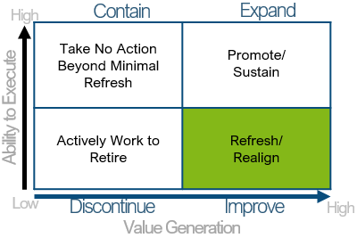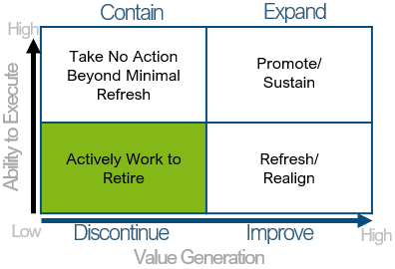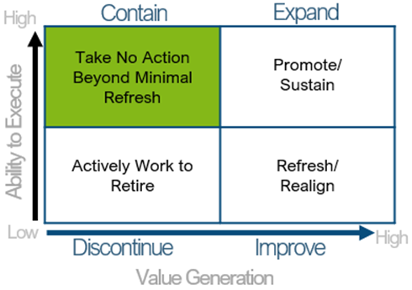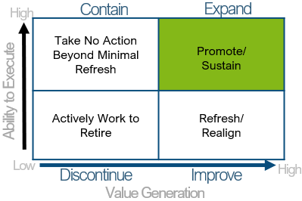~~

Figure 7: Example Quadrant Chart Decision Process

The largest issue of using this type of reporting tool is determining how to limit the information being given and the scale to use in analyzing each data point. The information being provided is impossible in organizations that control thousands of items; it is logical to utilize hierarchical systems instead of individual components. Deciding which level within the organization is how it first gets difficult. Limiting the information to a higher level in the system hierarchy also leads to the problem of determining how to rate each system for not every system is going to have the same level of value generation and similar ability to execute. To place data points in the graph, each item will require a numerical value for both subsets of data. This is the next hurdle an ITPM manager will face.

Once these scales have been defined, running each system through the analysis is primarily time-consuming but is now become more automated and mature. The final difficult portion of this reporting tool comes in the table set-up. First, you must establish a table in MS Excel with two columns representing the ratings of each system for both scales. Then you must create a chart within the table to capture the many data points. Once all data points are inputted then the dot plot graph can be realized.

The following is an example of a proper quadrant chart with dot-plot graphing. This is merely a representation of how data can be reflected in a brief or a report to assist organizational assessment of the portfolio.

Figure 8: Example Quadrant Dot-Plot Graph

**IT Budget Allocation**

Part of ITPM is to ensure a complete awareness of the portfolio to ensure efficient use of resources in the effort to identify areas of improvement. To identify if financial resources are being effectively utilized, a simple comparison chart can be provided to leaders in the effort to establish trend analysis; realize potential opportunities to reallocate unused funds into urgent, short term IT investment solicitation that have positive impact on the organization; and ensure timely dispersal of budgets in accordance with policies and regulations. Comparison charts can come in all shapes and sizes and can range from vertical cluster column charts developed in spreadsheet applications to more robust analysis tools such as Power BI Desktop and Tableau.

Each of these reporting options is scalable to equitably fit the agency’s needs. To meet the lowest-common denominator, a chart utilizing Microsoft Excel is displayed below to provide an example to executive leaders expressing IT budget dispersal versus authorized funding on a month-by-month basis. A combination chart could also be utilized with an associated line chart to show a cumulative expenditure of authorized funding for the organization.

Figure 9: Example Budget Allocation Chart

**Cost Savings from Legacy System Retirement**

As organizations mature in the industry they occupy, some systems will become out of date or no longer supported and in turn no longer support the organization’s direction. Legacy equipment, system and processes will need to be replaced at these events. To provide a cost-savings analysis of budgetary effects for replacing those systems, a side-by-side comparison utilizing graphical data showing potential savings from either removing the capability or transitioning to another newer and more efficient system. The following example can help provide some guidance of how to provide this representation in reports.

Figure 10: Example Cost Savings from Legacy System Retirement Chart Comparison

**Comparative Year Over Year Overview (YOYO) Financial Report**

The portfolio requires executive direction to ensure focused future use is promoted through continuation of current spend plans, a realignment of spending plans to more mirror the direction expected, or a complete restructuring of IT initiatives within the organization. A comparative YOYO financial report can provide multi-factor trend analysis reporting for executive teams to review how agency budgets are being disbursed over time which then can have a significant impact on the efficiency and effectiveness of future spend plans. To express this productively for leaders, a few reporting methods can be used.

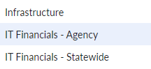 First, a stacked, 3-dimensional pie chart can be used to reflect multiple years of spending by tower. For the State of Washington utilizing Apptio report functions, the method to collect this data is to look at the “IT Financials – Agency” Reports Collection and navigating to the “Agency Spend” tab.

Figure 11: Apptio Menu Selection

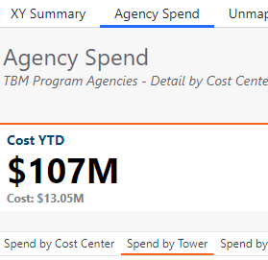Selecting “Spend by Tower” will display multiple data sets that show a numerical breakdown of spend by IT tower by spreadsheet, by horizontal line graph, and by pie chart. Hovering your mouse cursor over the pie chart and right clicking the chart will display a menu of selections. Selecting “Open Chart Image” will download a .png image file to your computer. This can be inserted into reports for leadership teams to see the spending per tower. Combining multiple images into the report will allow leadership to see trends developing and as a portfolio manager you should be able to decipher the images for them. The downside of proceeding with the image download is that each section will be different colors per tower depending on the hierarchy of spend amounts. The spending will change from year to year and may confuse executive teams if they associate color with tower.

Figure 12: Spend by Tower Selection

To fix this issue, selecting the “Open in Excel” will allow you to import the data in table format and you can insert a pie chart into the excel spreadsheet. Opening multiple years of total spend by IT tower allows you to combine the data and move fields around so that each tower is represented by a particular color. This allows leadership to see the changes year over year and provides a report that reads more conclusively.

With the above representation, you can see that the “End User” spend decreased dramatically while the “Data Center” and “Security and Compliance” spend increased. If the agency is attempting to grow Data Center portions of the portfolio and enhance security and compliance efforts while reducing end user spending this will show leadership teams that the agency spend plan is meeting their vision for the organization. The raw data from Apptio automatically lists IT tower spends in a descending order. Graphical representation in Excel then assigns dark blue to the first cell in the list and as such, would have placed Networks as dark blue on the second pie chart.

## ITPM Maturity Efforts

Any organizational program should strive to evolve and become more efficient and effective for organizational improvement. This continual process improvement should be focused on not necessarily bringing in new enhancements but to improve the existing policies and streamline them to maximize established efforts. Many organizations lack a functioning ITPM program, and a good starting point is found in the MIT Sloan Management Review article from Spring 2004 by Mark Jeffery and Ingmar Leliveld. To abbreviate the article, certain portions provide a view of where to start an ITPM program and how to conduct ITPM maturity efforts.

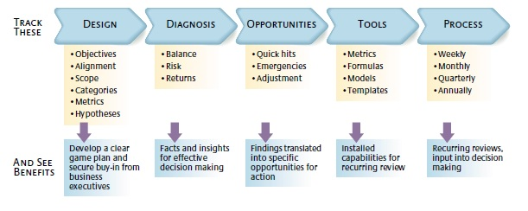

Figure 13: Creating an ITPM Program[4]

The first stage of ITPM maturity is to create and document a robust ITPM program. There are many aspects from this guide that can help you establish an ITPM program. Figure 13 helps provide an overall process of determining an organization’s program. Some processes that should go into creating a process should be developing an organizational guide for the respective ITPM program, a guide for business owners so they understand the requirements needed for the ITPM program manager and what they should expect from them, and a basic outline of the organization’s vision, mission, and goals to ensure that portfolio efforts are being made in line with the organizational alignment. Metrics of how the ITPM program will analyze the portfolio will vary from organization to organization based on the size and scope of the agency and each will have varying levels of need to understand risks, review, and other aspects of portfolio analysis.

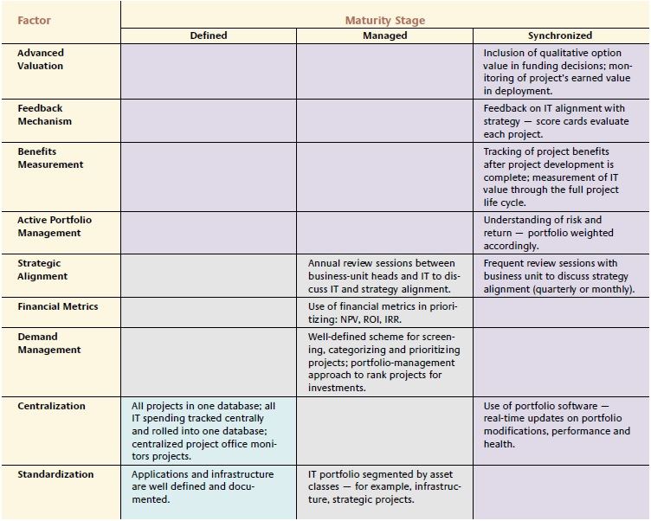

Figure 14: ITPM Maturity Levels[5]

ITPM programs should strive to mature to a synchronized level where all aspects of the ITPM program are operating near-autonomously with little intervention of the portfolio manager. A full, strategic view of the program that will allow executive leaders the capability to make high-level decisions on the direction of the portfolio is the goal of a fully mature program. Figure 14 provides a quick reference towards the levels of maturity that an organization should meet.

**Change Management Process**

To allow for a positive change management process of the ITPM program, business owners will submit an E-mail with the proposed program change to the IT portfolio manager. The current IT portfolio manager for WaTech is found in the Contact section on the following page.

**WaTech Maturity Model**

Table 1: WaTech Maturity Model

|  |  |  |  |  |  |
| --- | --- | --- | --- | --- | --- |
| **Maturity Level** | **Description** | **Defined** | **Managed** | **Synchronized** | **High Functioning Program** |
| Level 0 | The Agency has assigned IT applications, infrastructure, projects, and contracts (assets) but has a recognized lack of program, governance, project tracking, and inventory control. |  |  |  |  |
| Level 1 | The Agency has a defined program but no documentation. The program has documented assets and spending is tracked centrally in one database. All projects are centrally monitored. The program lacks coherent governance and centrally tracked inventory. | **X** |  |  |  |
| Level 2 | The Agency has a defined and documented program. The program has documented assets and spending is tracked centrally in one database. All projects and inventory are centrally monitored and tracked but is not synchronized. Some governance is documented but lacks full clarity. The Agency has at least an annual review of strategic alignment with business owners. Financial metrics are used in prioritization of IT asset procurement. This prioritization also includes screening, categorization, and prioritization of IT projects through ranked investment recommendations. | **X** | **X** |  |  |
| Level 3 | The Agency has a defined and documented program that utilizes portfolio software. The portfolio software uses real-time updates on modifications, performance, and health. The program has documented assets and spending is tracked centrally in one database. All projects and inventory are centrally monitored and tracked and are synchronized. Governance is clear and fully documented. Business owners and other stakeholders provide frequent review sessions to ensure portfolio alignment with strategic goals of the Agency. Financial metrics are used in prioritization of IT asset procurement. This prioritization also includes screening, categorization, and prioritization of IT projects through ranked investment recommendations and risk strategies are actively weighed. IT project value is measured actively through the project life cycle. | **X** | **X** | **X** |  |
| Level 4 | The Agency's well-defined and documented program includes qualitative factors to measure IT asset deployment. Feedback is provided to the IT portfolio manager for continual re-alignment of the portfolio with strategic goals. Clear and concise governance is widely disseminated, and business owners are fully trained on program processes. The agency has joined IT associations in the effort to improve internal processes and share advancements in the realm of IT portfolio management. | **X** | **X** | **X** | **X** |

# Contact

Questions regarding the WaTech ITPM Guide can be directed to:

Jeremy Schlake

WaTech IT Portfolio Manager

[jeremy.schlake@watech.wa.gov](mailto:jeremy.schlake@watech.wa.gov)

# References

Jeffery, M., & Leliveld, I. (2004, Spring). Best Practices in IT Portfolio Management. *MIT Sloan Management Review, 45*(3), pp. 40-50. Retrieved January 26, 2023

1. https://info.flexera.com/ITAM-REPORT-State-of-IT-Asset-Management
2. https://news.gallup.com/businessjournal/152429/Cost-Bad-Project-Management.aspx
3. https://ocio.wa.gov/enterprise-technology-dictionary
4. From MIT Sloan Management Review article by Mark Jeffery and Ingmar Leliveld
5. From MIT Sloan Management Review article by Mark Jeffery and Ingmar Leliveld